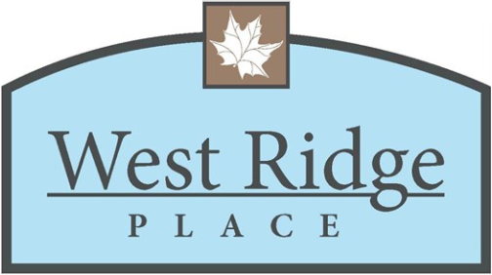 | WEST RIDGE PLACE HOMEOWNERS ASSOCIATION  2172 West Nine Mile Rd, Box 207  Pensacola, Florida 32534-9413

